Braze sGTM Proxy Client — Setup Documentation
Thank you for purchasing the sGTM Client Template for Braze™ Proxying!
This document contains the step-by-step documentation to successfully import, configure, and integrate the template into your server-side Google Tag Manager setup and frontend environment.

🛠️ Step 1 — Import the Template into sGTM
- In your Google Tag Manager Server Container, navigate to Templates on the left-hand menu.
- In the Client Templates section, click the New button.
- Click the three vertical dots (top-right contextual menu) and select Import.
- Choose the downloaded file: custom-client-braze-proxy.tpl
- Click Save in the top right corner and close the template editor panel.

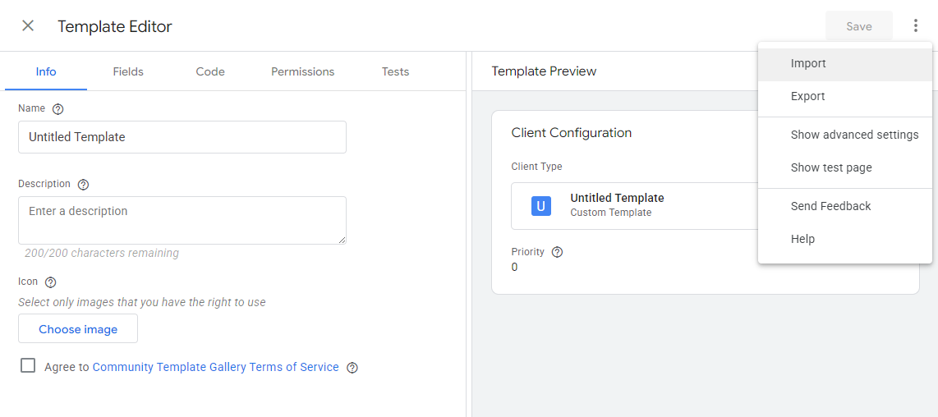
⚙️ Step 2 — Create and Configure the Client
- Navigate to Clients in the left-hand menu and click New.
- Click on Client Configuration and select your newly imported Braze Proxy Client.

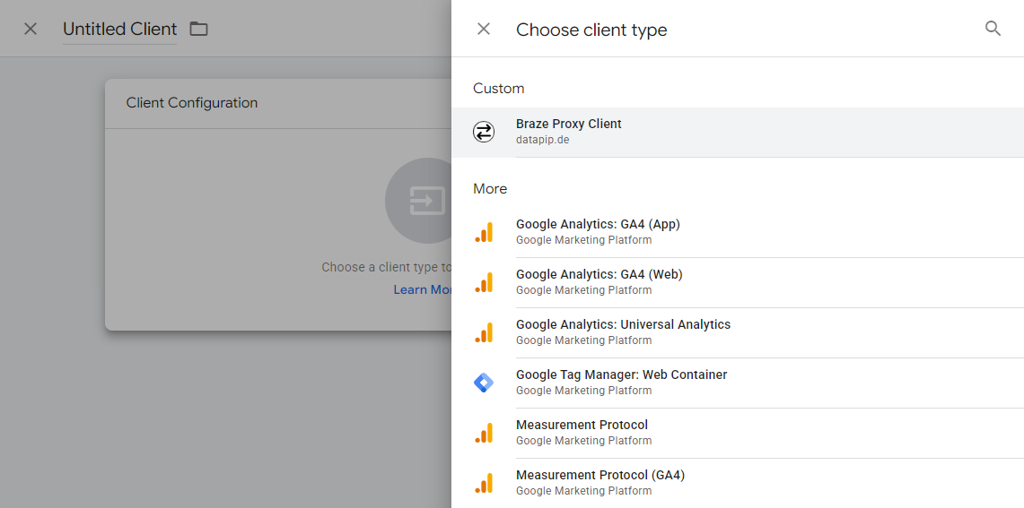

- API Endpoint: Enter your project-specific Braze SDK endpoint (e.g., https://sdk.ex-01.braze.eu). You can locate this string in your Braze Dashboard under Settings > App Settings > SDK Endpoint.
- Allowed API Keys (Recommended): Enter your authorized Braze Web API key(s) to strictly secure your infrastructure endpoint against unauthorized proxy use. You can locate this string in your Braze Dashboard under Settings > App Settings > API Key.
- Allowed Origins: Specify your allowed website domains (e.g., https://www.yourdomain.com). Note: Ensure there is no trailing slash at the end of the URL string.
- Assign a recognizable name to the client (e.g., Braze Proxy) and click Save.

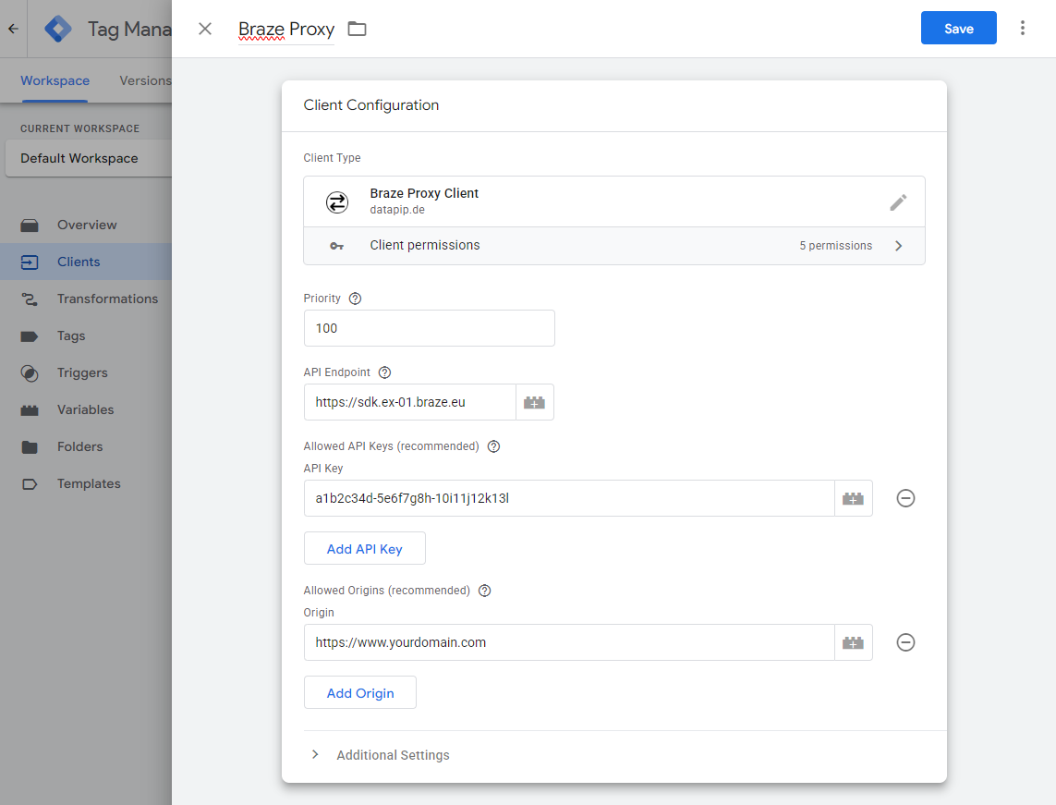

💻 Step 3 — Update your Website Integration
To actively route your frontend tracking traffic completely through your server-side container infrastructure, apply the following two code alterations to your codebase:
1. Load the Web SDK
Follow the documentation on how to install the Braze library via Braze CDN as described here: https://www.braze.com/docs/developer_guide/sdk_integration . Adjust the script src attribute to pull the minified library file straight from your own sGTM tracking instance domain wrapper instead of the standard public vendor CDN asset:
<script type="text/javascript">
+function(a,p,P,b,y){a.braze={};a.brazeQueue=[] ... // Note: this code is shortened
y.src='https://data.yourdomain.com/web-sdk/6.7/braze.min.js';
y.async=1;(b=p.getElementsByTagName(P)[0]).parentNode.insertBefore(y,b)
}(window,document,'script');
</script>
2. Initialize the Braze Web SDK
Point the baseline URL property directly to your custom sGTM domain environment:
braze.initialize("YOUR-API-KEY", {
baseUrl: "https://data.yourdomain.com",
// All other initialization options remain completely unchanged
});

⚖️License, Support & Conditions
- License Scope: Single-company license. This commercial transaction grants operational deployment rights exclusively to the purchasing business entity/organization for internal domain infrastructures.
- Product State & Warranty: This asset is sold strictly as-is based on its current stable development release state. No automated future compatibility updates or maintenance lifecycles are guaranteed following potential breaking changes to internal Braze structural API layers.

